ABOUT US

LONDON BEDS mattresses represent the artistic and traditional way with personalized approach worthy of the best tailoring in the art of making mattresses.

Our beds combine and apply covered technical processes in the industrial revolution of 1966 in tune with the fast paces of modern life, while reflecting classical European heritage and history in the art of rest.

Each mattress is sewn by hand for long-lasting strength. Finished with exquisite fabrics and embroidered with the name of LONDON BEDS Mattresses as a testimony of masterpiece and exceptional pleasure.

We like challenges and our desire is that your bed becomes an integral part of your life, giving you years of restful sleep and pleasure, placing LONDON BEDS Mattresses in a prestigious position in search of new ideas and comfort techniques.

LORD

LORD one side mattress, Indulgently cozy and flexible, is appreciated by our customers who are looking for great benefit with minimal cost. It is exceptionally resistant, with a level of standard firmness and a unique ability to recover and maintain its shape in the face of continuous use.

LIVERPOOL

Pillowtop mattress (two sides). Indulgently welcoming and flexible, it is appreciated by our customers who seek great profit with minimal cost. It is exceptionally resistant, with a level of standard firmness and a unique ability to recover and maintain its shape in the face of continuous use.

BIGBEN

A supremely functional mattress that provides impeccable support for the body, usable on both sides with different firmness between them, being the perfect place to take refuge from the world. Its cushioning unit and selection of internal fillers, work in harmony with the feeling of LONDON BEDS to create an environment of medium firmness and guarantee a perfect night's sleep.

ENGLAND

A sumptuous product, which presents at its core a support without shock absorbers being exceptional and compact. Composed of cassata with two pillows and fine fillings, it produces an exquisitely voluptuous ultra-firm feeling, for an unforgettable night's sleep. The ENGLAND mattress from LONDON BEDS results in a highly adaptable surface that responds very well to pairs of variable anatomies.

EXCALIBUR

The sublime EXCALIBUR Mattress, with an extra note of maximum luxury, offers a reassuring and traditional feeling. With double cushioning system and a sophisticated mix of fillers, it incorporates a feeling of high and medium firmness thanks to its two different faces that result in a relaxing combination of comfort without losing support, for a large audience and wide range of body sizes.

BUCKINGHAM

Our attractive BUCKINGHAM mattress was created to provide maximum sleeping comfort, with exceptional development, features softer shoulder and hip areas to relieve pressure points and a semi-firm lower back area to provide floating support and exquisite softness. With no resistance or pressure at the bottom, you will feel that you sink into bed almost weightlessly, but with enough depth to keep your spine straight, whether you sleep on your side, back or stomach. on the back of the mattress a higher level of orthopedic firmness is allowed that promotes well-being and health. a masterpiece of the best materials, traditional manufacturing, and meticulous attention to detail.

UNDERGROUND

When we designed the UNDERGROUND mattress, our purpose was simple: to surpass the other mattresses, redefine the limits of comfort, quality and ergonomics without regard to time or cost. The UNDERGROUND mattress from LONDON BEDS are comfort and exquisiteness on one side and on the other the perfect correction of orthopedics come true, handmade, conveys a feeling of luxury quality and design without barriers to your bedroom. It was created using unparalleled experience in mattress manufacturing, with a unique combination of bagged pocket shock absorbers and sumptuous filled with the best fibers, to provide the best sleep experience.

BASECAMA

The BASE-BEDS of LONDON BEDS are finely upholstered and designed to give you a relaxing and safe ergonomic night's sleep, as you have reinforcing legs in the central areas. It uses dry woods and are secured with sealant glue and agglomerated screws for maximum adjustment or strange noises when resting, also uses low or high legs and variety of colors to the preference of users.

HEADBOARD

Authentic and generous headboard designed by LONDON BEDS, made of synthetic leather or microfiber fabrics with and without buttons, with exquisite details such as hand-sewn seams and 10 cm legs to locate and lie on the wall. It's an elegant piece of furniture.

Es una elegante pieza de mobiliario {por derecho propio}. Esto no se traducirlo en español porque es como una frase que no se como la dicen los británicos, en ingles eso es ‘in its own right`. Pero queda redundante, por eso no lo puse

CAMANIDO

Charming bed with auxiliary trundle with drawers (optional) ideal for homes with purposes of optimizing their spaces or frequent visits, made of dry woods, and industrially reforested that guarantees durability.

SLEEPER SOFA

Sleeper Sofa with CLICK technology, three resting positions for comfort, has cushions or armrests, designed for domestic use, with practical baul to store objects and variety of colors.

YORK RECLINING CHAIR

The YORK Reclining Chair is designed to offer you the greatest relaxation and comfort for your back, lower back, and legs. Ergonomic design with independent recline at 150 degrees, lowering the seat back and raising the footrest.

MATERIALS

In each bed of LONDON BEDS the best materials are used and with systemss of bagged pocket shock absorbers or continuous biconics in the form of a honeycomb. Fibers keep you and your bed cool, dry, and clean.

Each spring moves intelligently in response to your body and your movements, offering personalized support and supreme comfort. The result is a deeply comfortable bed that provides a well-deserved restful sleep.

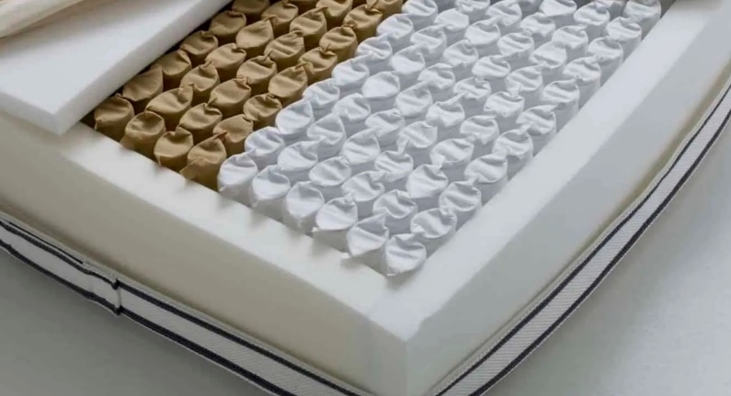 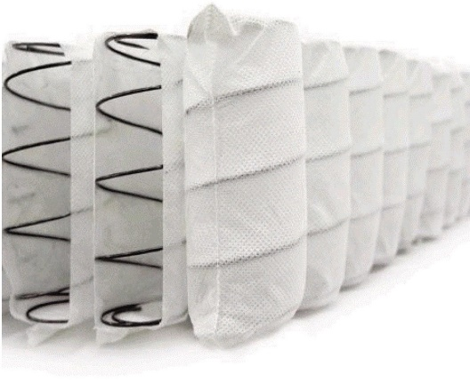

BAGGED POCKET

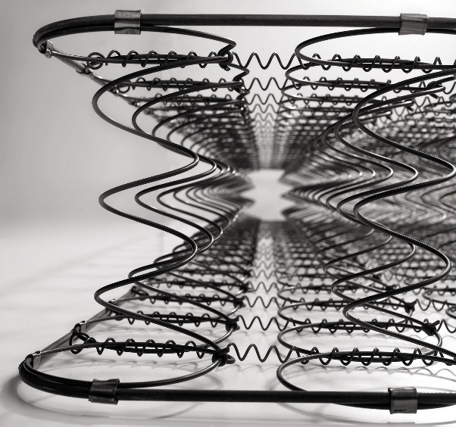 

CONTINUOUS BICONICS

MATTRESS SIZES



SINGLE

SMALL DOUBLE

DOUBLE SIZE

QUEEN

KING SIZE

SOCIAL RESPONSIBILITY

10 STEPS TO BETTER SLEEP

We live in difficult times, and you may think that, due to the frenetic pace of modern life, sleep is a luxury we can afford. However, from a medical point of view it is essential that you sleep well if you want to keep your immune system well strengthened and your body and brain healthy.

Indeed, lack of sleep can ruin your health, make you gain weight, weaken your immune system and cause chronic stress. It is true that sleep is what almost all of us crave at the end of a long or busy day. But alas, many of us don't sleep as much as we should. Scientists are beginning to understand the huge impact this has not only on our health, but on the future of our brain. So how does sleep affect our brain?

Sleep may play a unique role in the development of many cognitive decline diseases. In fact, the quality of your daily sleep can increase or decrease your risk of getting such diseases. Yes, we already know that quality sleep is important above all to have a healthy immune system. Apparently, sleep influences appetite, metabolic rate, weight, the immune system and, believe it or not, our way of thinking, our decisions and even our emotional state.

This means that sleep influences many aspects of how our brain works. Let's discover our ten favorite steps to sleep better.

STEP 1: ALLOW YOURSELF AT LEAST SEVEN TO NINE HOURS OF SLEEP

Like the nature clock, have a few regular hours of going to bed and getting up, even on the weekend; it is one of the most important steps to enjoy a perfect night's sleep. This step is vital because it sets the perfect rhythm of the body's circadian cycle. When you wake up and open your eyes each morning, the light that enters them resets the circadian cycle. By doing it on a regular basis, you are programming your brain to know what it does and when it should do it each day. Opt to stick to the same sleep schedule seven days a week, and you'll have taken a big step toward the goal of improving your sleep.

STEP 2: AVOID ALCOHOL THREE HOURS BEFORE BEDTIME

Surely, it's okay to occasionally enjoy an alcoholic beverage at night. But if that glass of wine or beer is too close to bedtime, it may affect the quality of your sleep, because your body will still be digesting alcohol when you lie in bed. Ideally, you should let about three hours pass between your last drink and the time to turn off the light, so that you can digest the alcohol properly. This will limit the possible negative effects it has on your sleep.

STEP 3: AVOID CAFFEINE STARTING AT 2:00 P.M.

Maybe you feel the need to use the coffee maker when the midday dream invades you... But this is a practice that can affect the quality of your sleep. Remember that the effect of caffeine lasts between six and eight hours; therefore, it is important to stop taking caffeine at 2:00 p.m. If you plan to go to bed around or before 10:00 p.m. Did you know that a cup of coffee of about 250 ml contains about 100 mg of caffeine? That means a cup of coffee at 4:00 p.m. is equivalent to still having 50 mg of caffeine in the body at 10 p.m.!

STEP 4: GET SUNLIGHT AND HYDRATE IN THE MORNINGS

Sunlight stops the emission of melatonin in the brain. Melatonin is the natural hormone that regulates sleep. Sunlight helps the brain and body wake up, setting the pace of your circadian cycle. Within thirty minutes of waking up, drink at least one glass of fresh (never cold) water to hydrate your system. Go outside or open a window to receive direct sunlight.

STEP 5: EXERCISE REGULARLY

Exercising during the day will help you strengthen your circadian cycle, be more alert during the day and even feel drowsy when it comes time to turn off the light. Of course, avoid doing intense physical activities before going to bed, as this can raise your body temperature and impair sleep. If possible, take your time to relax before bedtime.

STEP 6: REFRESH YOUR ROOM BETWEEN 18 AND 22 DEGREES AT NIGHT

Your sleep cycle follows the cycle of your body temperature, and at night, your temperature drops. For your brain, this drop is a sign that it's time to sleep. Sleeping in a cooler environment favors this process, as it helps you fall asleep more quickly and easily.

STEP 7: AVOID BLUE LIGHT AT NIGHT

Blue light emitted by electronic devices such as mobile phones, televisions and computers blocks the brain's production of the hormone melatonin. Excessive exposure to blue light before bed will impair your sleep. If you can't avoid screens in those later hours of the day, wear glasses that block blue light two to three hours before bedtime.

STEP 8: PRACTICE MEDITATION BEFORE BED

Practicing meditation before bed is one of the best ways to relax the mind and body and prepare for sleep. Breathing exercises, progressive muscle relaxation and guided meditation soundtracks of the RESTORE app are some of the most used resources by users.

STEP 9: GET TESTED FOR SLEEP APNEA

Sleep apnea is a common sleep disturbance, and about 70% of people who suffer from it have not been diagnosed. To get all the advantages offered by sleep, it is not enough to know how many hours you spend asleep, but also what happens during those hours. If you don't feel restful when you get up, think about getting tested to make sure you don't have sleep apnea.

STEP 10: ASK YOUR DOCTOR ABOUT SLEEP SUPPLEMENTS

There are several sleep supplements that may help you improve the way you sleep at night. If you have the chance, talk to your doctor about the various nutritional supplements that might help you sleep better. For example, for many people magnesium and melatonin can be beneficial.